Milestone 1 (Alpha)

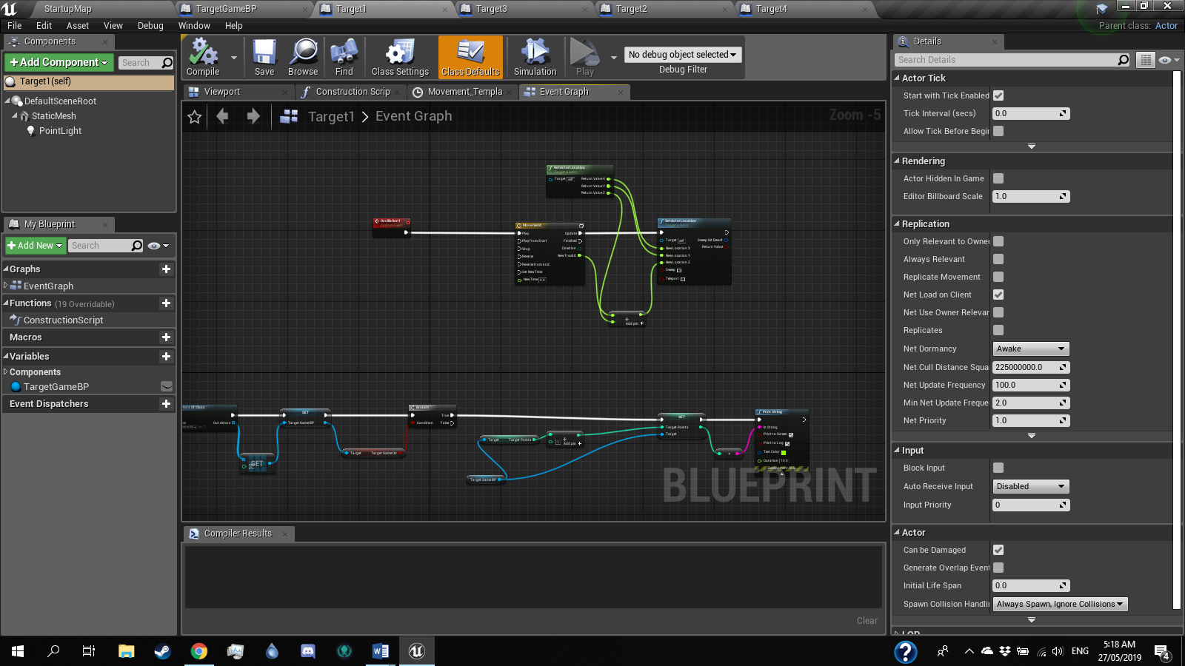In this build, the core mechanics are complete, which are used for the target game. They will now be applied to the other two games. This includes the points system, buttons, and events such as animation for the targets and adding points when a target is hit.

I have decided to make the other games physics based games similar to the target game, that will follow a similar basis and using objects like the balls, but with different goals. I currently plan to create a game where the player must throw balls into hoops and reach a certain number of points within a time limit, and a game where the player must hit targets with a hammer to reach a certain number of points within a time limit.

The hoop game will have moving hoops similar to the targets in the target game, which ill rely on overlap triggers rather than collision triggers to add points. The trigger will activate when a ball reaches deep enough into the hoop, to avoid points being added when the ball only hits the rim of the hoop.

For the hammer game, the targets will constantly appear and disappear, making the game more about the players speed than their aim.

I will also create spawning blueprints for the minigames. For the target and hoop games, a spawner that will spawn throwing balls constantly when the games are activated, and for the hammer game, a button that will spawn a new hammer if the player loses theirs.